Spring 2024: CS5720 Neural Networks & Deep Learning - ICP-1
Belli Anusha Sree (700758644)
1. Write a python program for the following:
– Input the string “Python” as a list of characters from console, delete at least 2 characters, reverse the resultant string and print it.
Sample input:
•python
•Sample output:
•ntyp
– Take two numbers from user and perform at least 4 arithmetic operations on them.
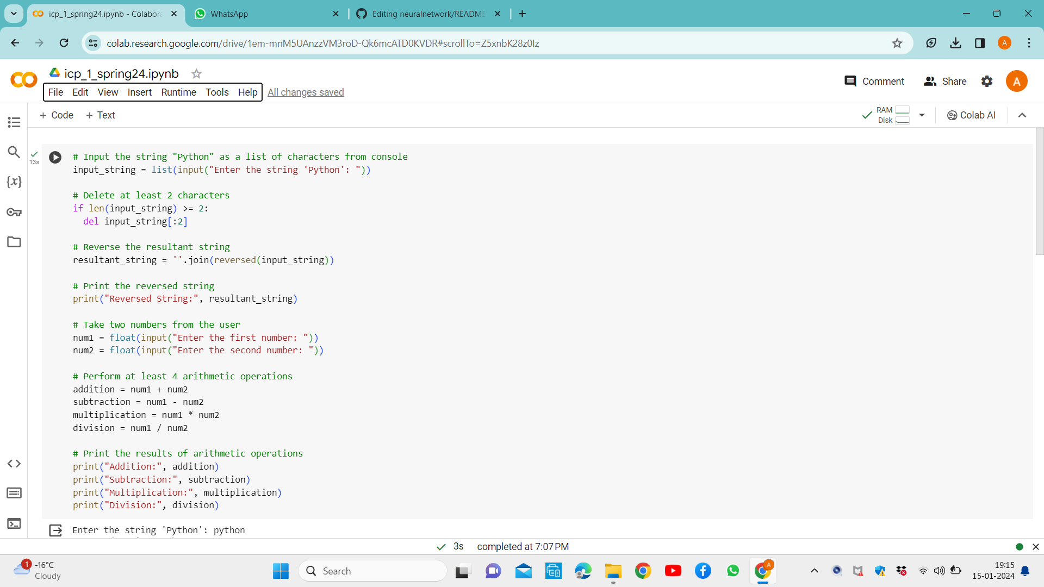

Output:

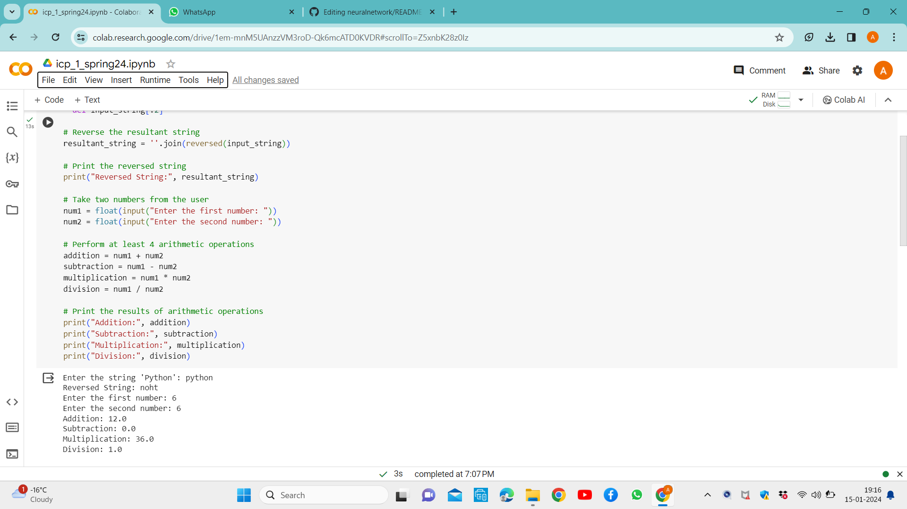

2. Write a program that accepts a sentence and replace each occurrence of ‘python’ with ‘pythons.
•Sample input:
•I love playing with python
•Sample output:

•I love playing with pythons
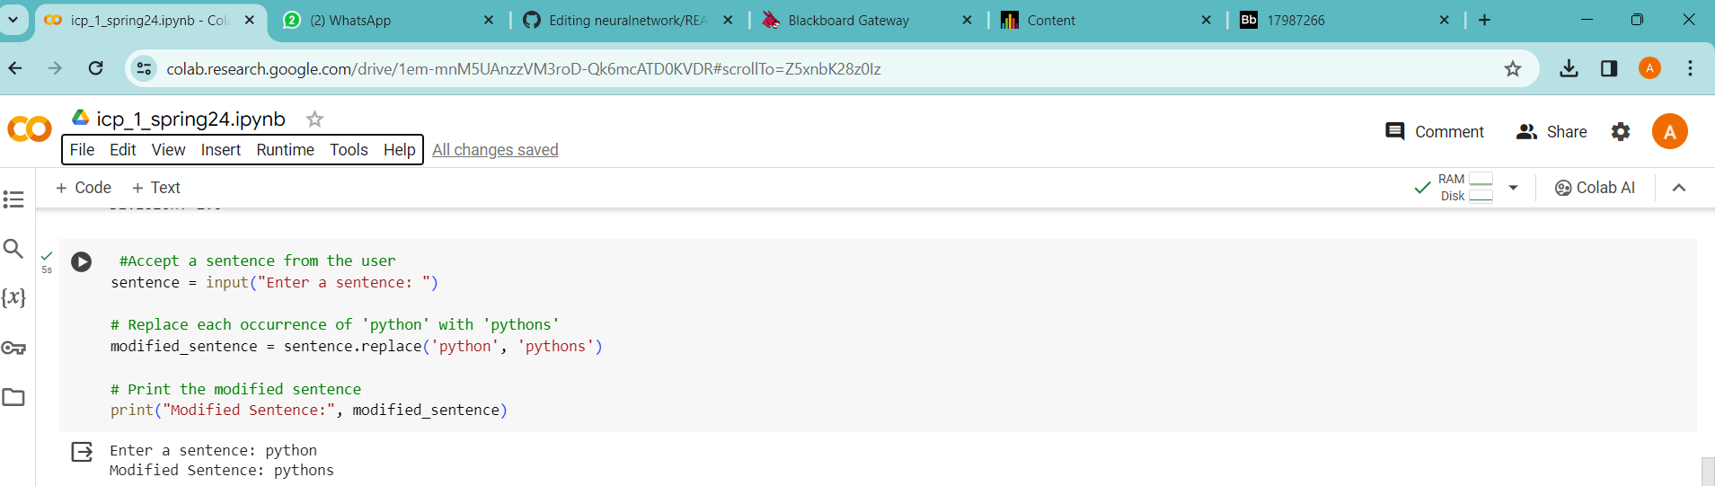

3. Use the if statement conditions to write a program to print the letter grade based on an input class score. Use the grading scheme we are using in this class.
